Programming for Computer Games

Designing and creating a basic 2d game

Question 1a:

Two different game engines are Unity and GameMaker. The following are some advantages why I will be using Unity.

* Unity has a bigger community. This might be because it is free of charge. Having a bigger community means that the support will be better. There are more tutorials, assets and will less likely be abandoned in the foreseeable future.
* Unity makes use of C# which is superior to GML in every possible way. C# is more popular, and can be easily learnt especially by those who have a C or Java background.
* It has an impressive and intuitive editor. It allows the gameplay to be paused and the variables to be changed at any time while the game is running.
* It makes use of a modular system and usability that allows the user to quickly develop a prototype of an idea. It consists of features like drag and drop, shaders and animation.

(Gamedev, 2016)

Question 1b:

C# and Python are two programming languages which are used in game development. The following are some features related to C#.

* C# is a simple modern object-oriented language which is derived from C++ and Java.
* The data types and classes are common to all the .NET languages.
* Visual Studio supports C# which provides access to the Microsoft .NET platform.
* Memory management and certain C++ problems are taken care of by Microsoft.

(Ganesh, 2017)

Question 2a:

The following state diagram contains an overview of the whole game.

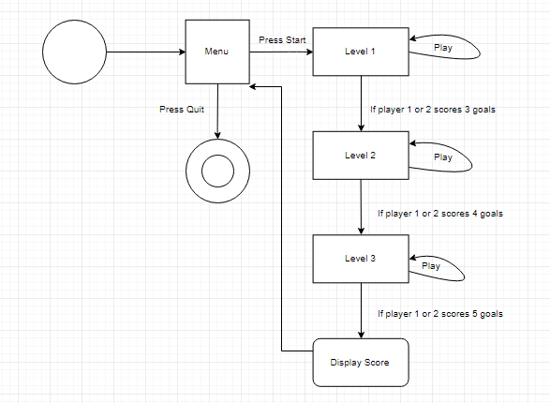

Question 2b:

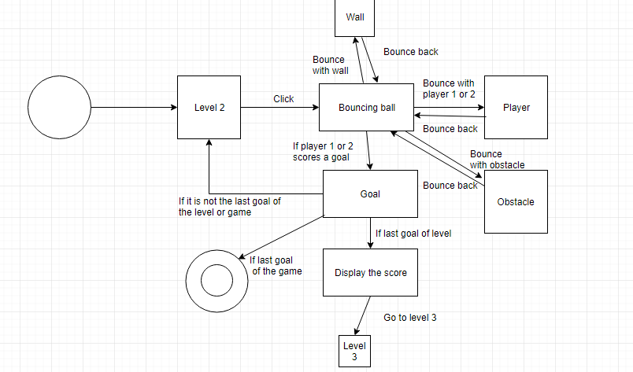The following is a detailed state diagram of level 2.

Question 3:

Multimedia files such as images, videos and audio consume lots of hard disk space. Since compression makes files shrink, it is ideal to compress such files to make them smaller and more practical to store and share. It also allows you to bundle multiple directories and files together. When compressing a file, you are removing repetitious and redundant information. Old images which are only there for the record, can be compressed and saved onto a CD for safe keeping while saving space on your hard disk. If you are going to use media files on a website, it is ideal to use a lossy compression on your image and media files to save the bandwidth and will help to load the pages faster.

The following is an example of file compression. This is the pdf size before compression.

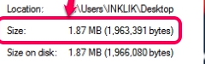

This is the pdf size after compression.

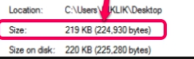

# Bibliography

Anon., 2017. *GameDev,* s.l.: lastninja2.

Gamedev, 2016. *Reddit.* [Online]   
Available at: https://www.reddit.com/r/gamedev/comments/5eaxgv/unity_vs_game_maker_for_2d_games_discussion/  
[Accessed 28 11 2017].

Ganesh, G. A., 2017. *SharpCorner.* [Online]   
Available at: https://www.reddit.com/r/gamedev/comments/5eaxgv/unity_vs_game_maker_for_2d_games_discussion/  
[Accessed 28 11 2017].

